Homelessness
Impact Score
0 10.5 30
Individuals who do not have a permanent residence, including those who are sheltered and unsheltered. This condition can touch individuals and families, all genders, and all age groups. Though there are many who suffer chronic homelessness, others will be at risk and suffer homelessness for shorter periods.

Health Impacts  Increased risk of:  - Mental health disorders  - Substance abuse  - Tuberculosis  - Hypertension  - Asthma  - Diabetes  - Sexually Transmitted Infections  - HIV/AIDS.  179 homeless people per 100,000 persons, annually  Source: Point-in-time estimates CHIP | Comparison  Homelessness, Marion Co. vs. other locations, 2017  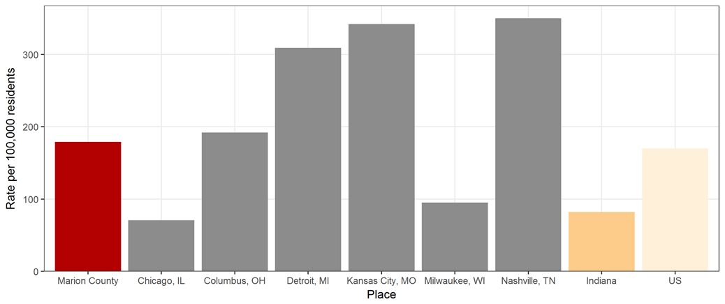  Source: US Department of Housing and Urban Development

Treatment
- Permanent supportive housing
- Increase employment and income
- Make support services more accessible

Trend
Marion Co. Homelessness, 2014-2018
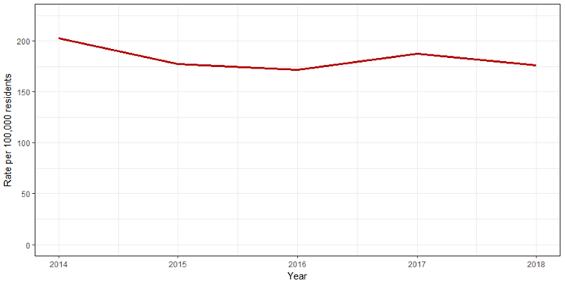
Source: Coalition for Homelessness Intervention & Prevention

Risk Factors
- Low income
- Loss of income or unemployment
- Prior imprisonment
- Prior history of homelessness
- Mental health issues
- Substance abuse
- Lack of family/community support
- Fleeing or attempting to flee domestic violence
Source: National Alliance to End Homeless

Equity
Homeless Adults by Race/Ethnicity, Marion Co. January 2018
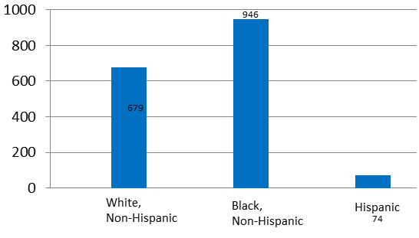
Source: Point-in-time estimates CHIP
Where People Live  - On the streets  - Camping outdoors  - In cars or abandoned buildings  - Staying in emergency shelters or transitional housing  - Staying with friends or family temporarily  Source: Substance Abuse and Mental Health Services Administration | Indianapolis Point-In-Time Count  On January 24, 2018:  - Approximately 12% of homeless adults were chronically homeless  - There were 128 families who experienced homelessness including 383 individuals in which 251 of them were under the age of 18  - Majority of school-aged children experiencing housing instability were in Indianapolis Public Schools (IPS)  - A total of 261 veterans were homeless  Source: Coalition for Homelessness Intervention & Prevention

